# Create an Article (Blog):-

Navigate to website (ec2-54-158-15-145.compute-1.amazonaws.com).

From top navigation chose “Submit an Article” link. If not logged in user will get login page as below:-

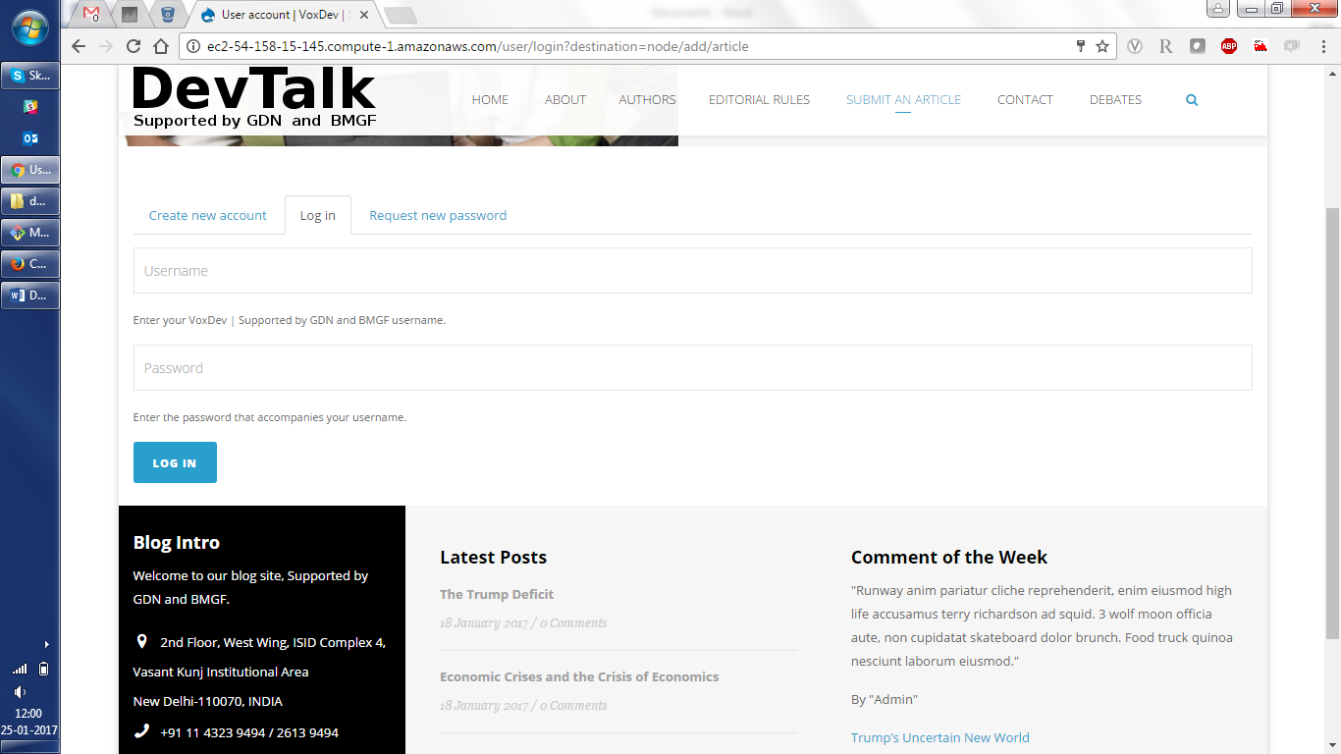

Enter your account details for author below is sample details:-

Username: - johndoe

Password: - front@123

Enter details and click on Login button as bottom. You will be redirected to add article page.

If you are logged in then you will redirected to add article page as below:-

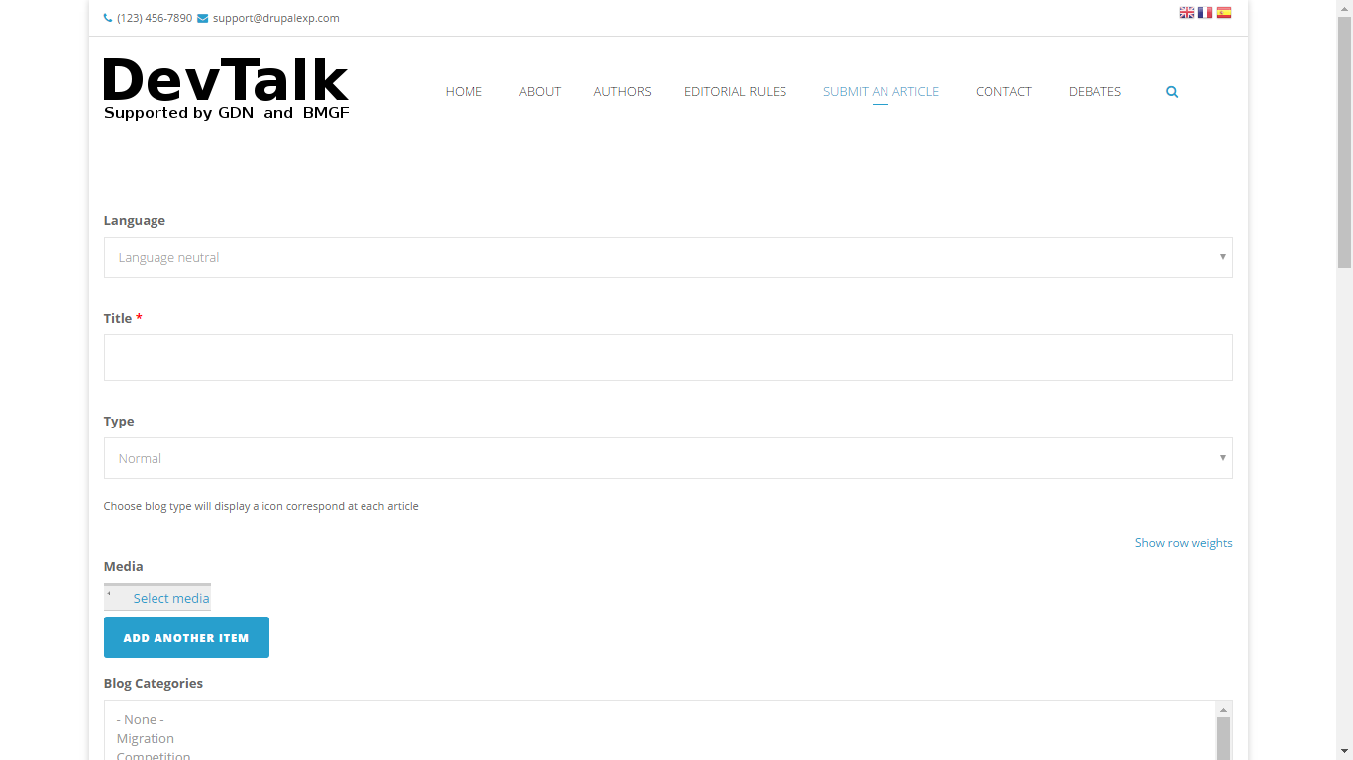

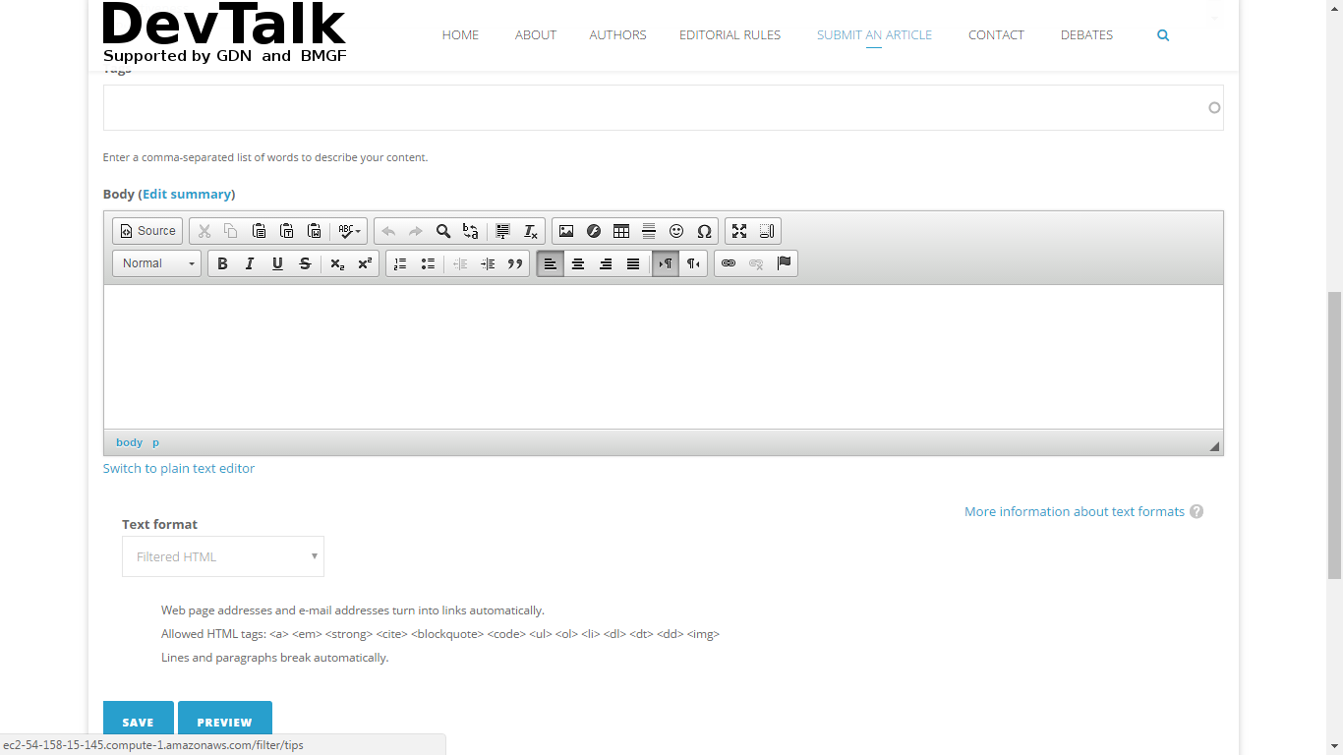

Fill the appropriate details in form and click on same. Your article will be submitted for review and publishing at admin end.